1 .Git Setup <https://confluence.atlassian.com/bitbucket/set-up-git-744723531.html>

Ans :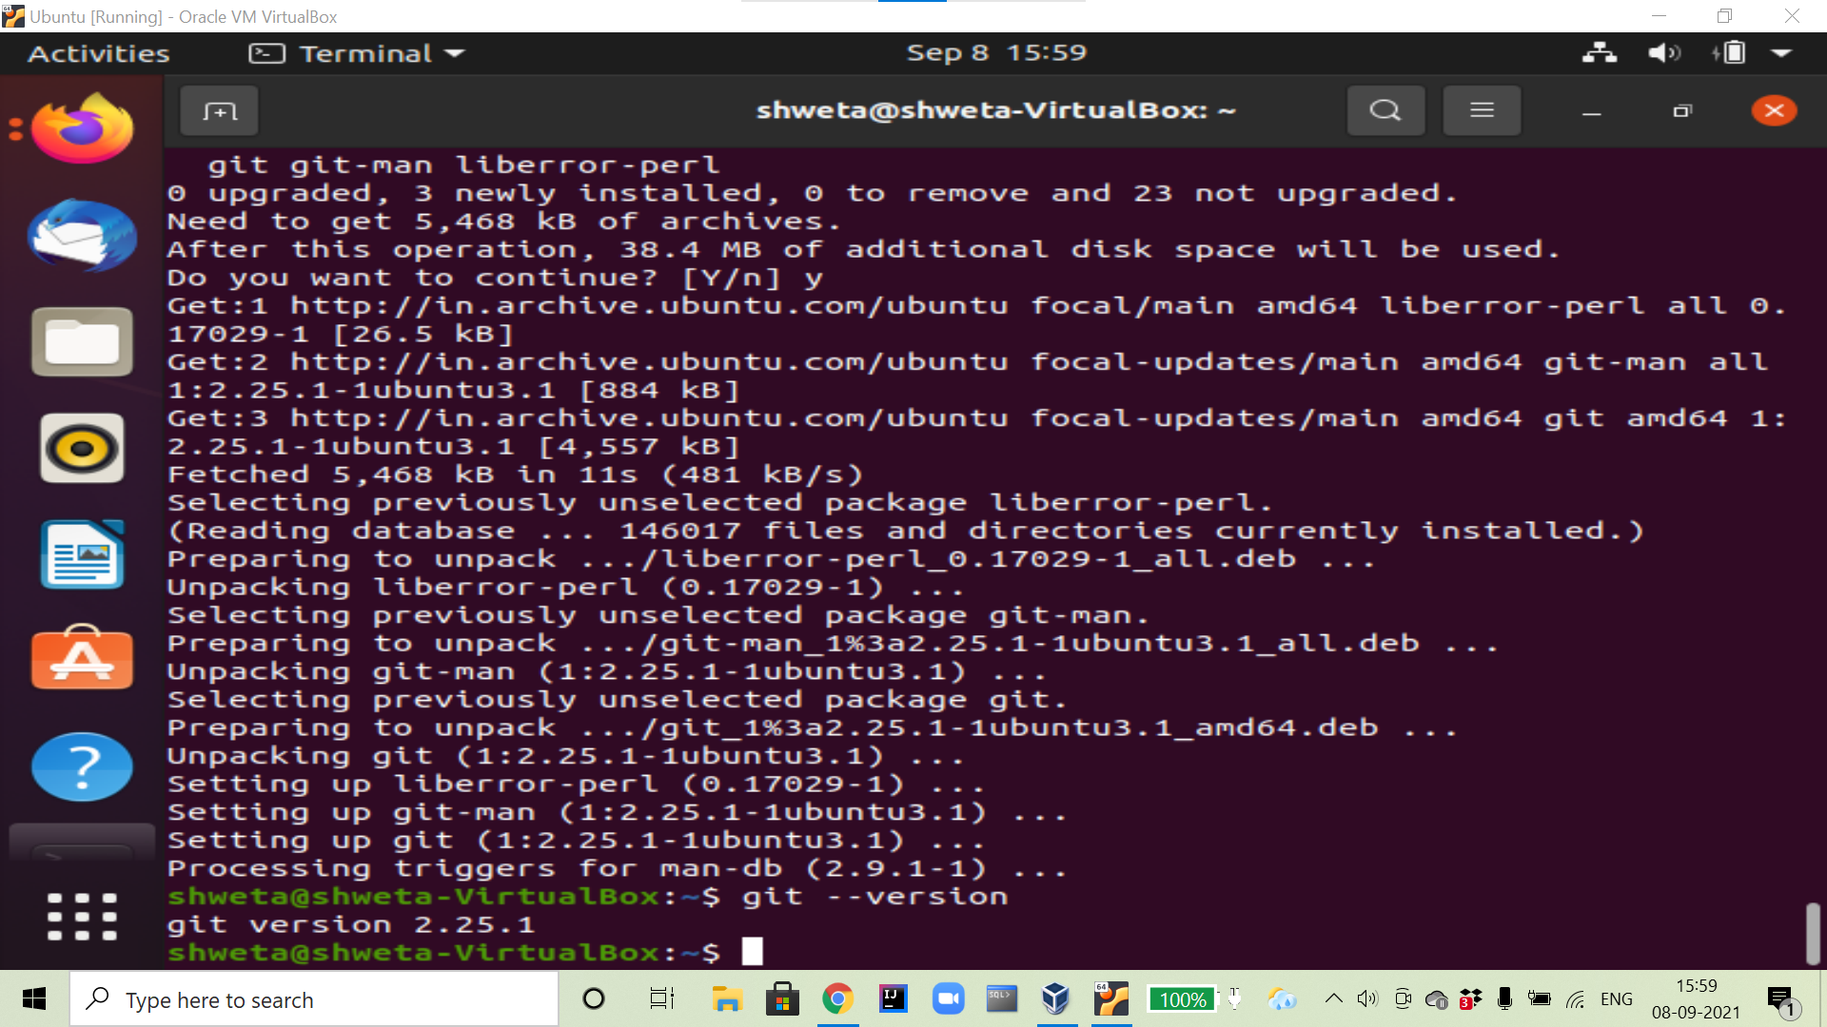

2. Initialize a Git Repository.

Ans :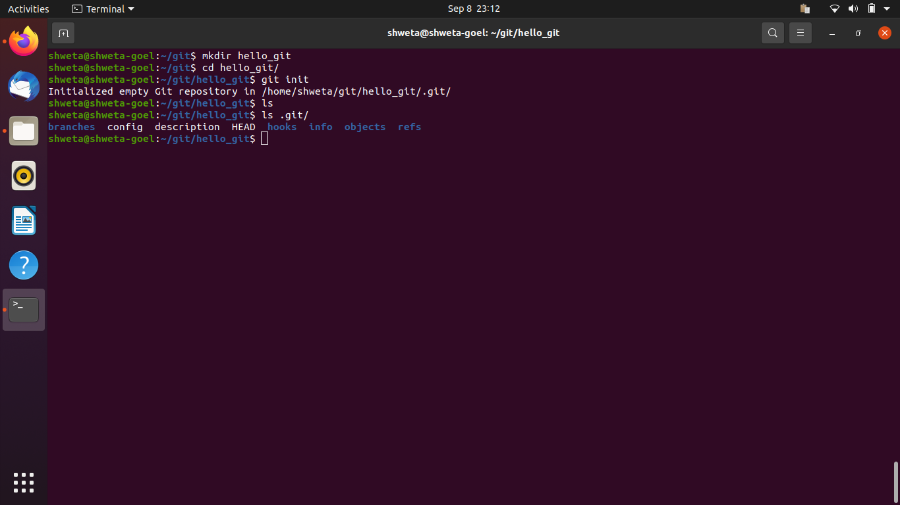

3. Add files to the repository.

Ans :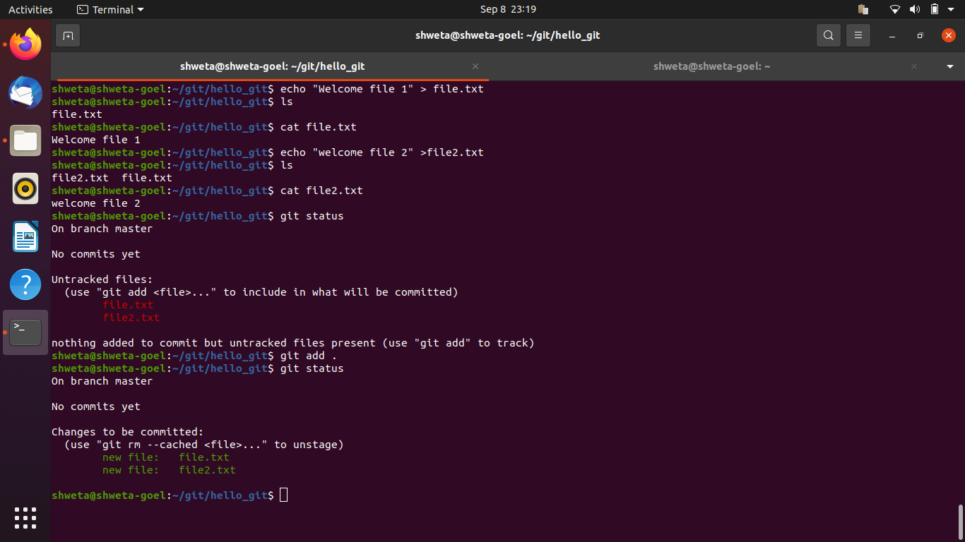

4. Unstage 1 file.

Ans :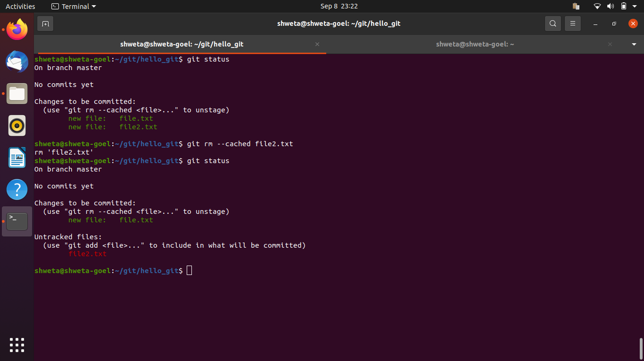

5. Commit the file.

Ans :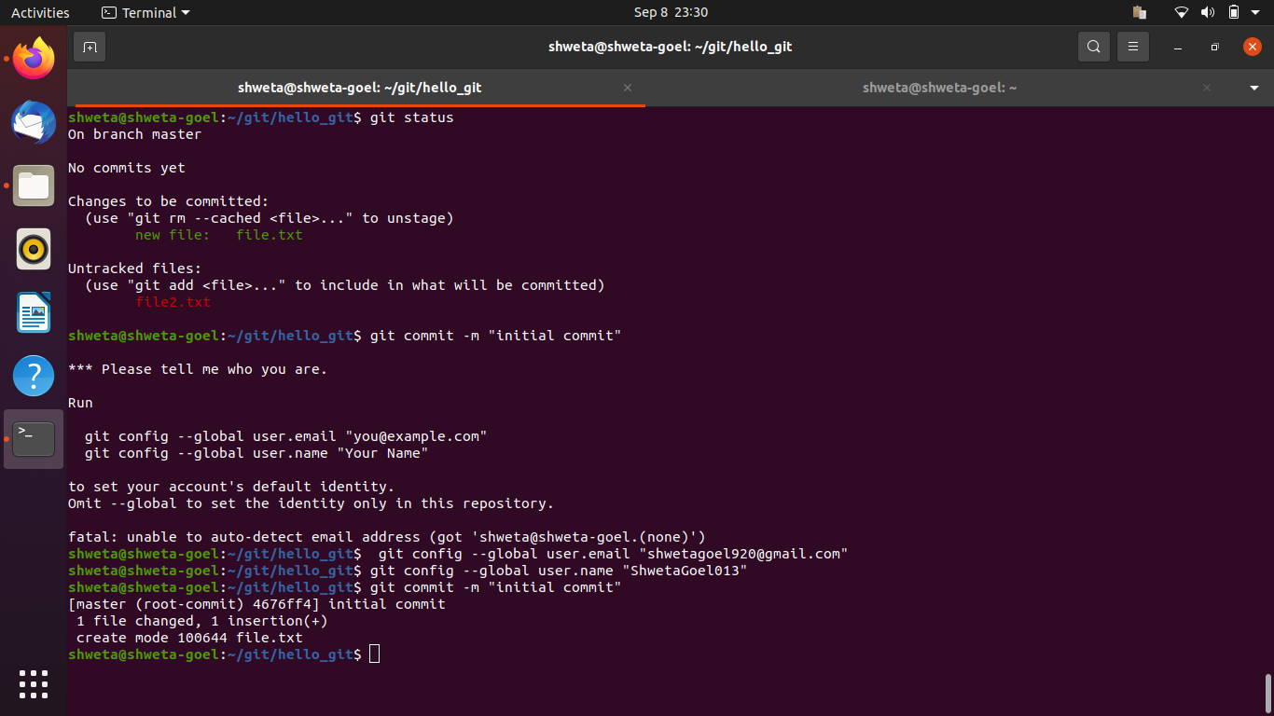

6. Add a remote.

Ans :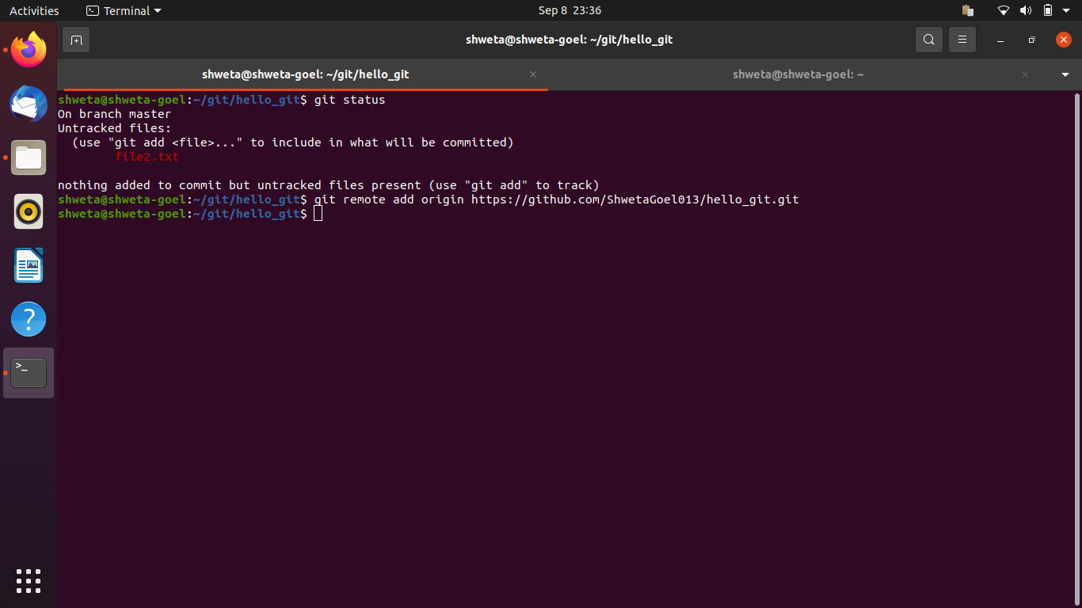

7. Undo changes to a particular file.

Ans: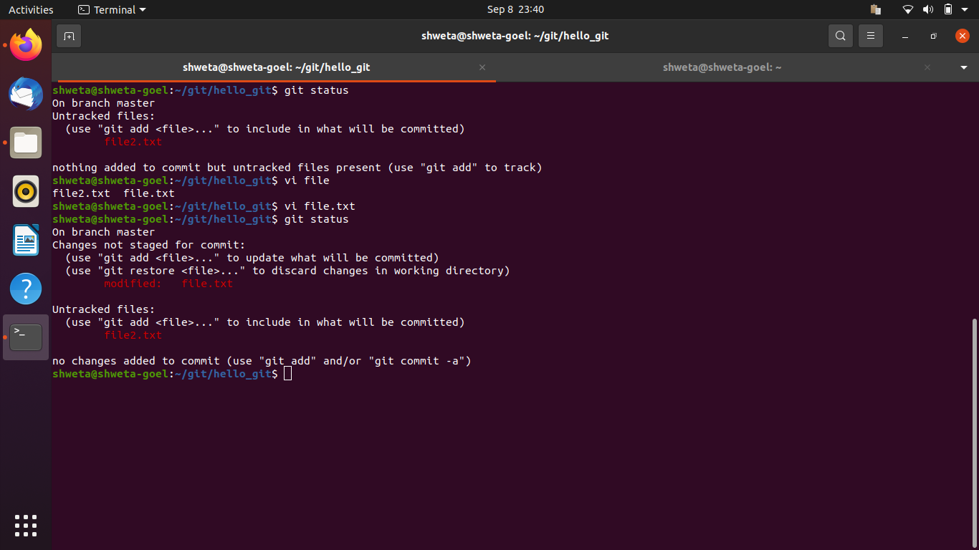

8. Push changes to Github.

Ans :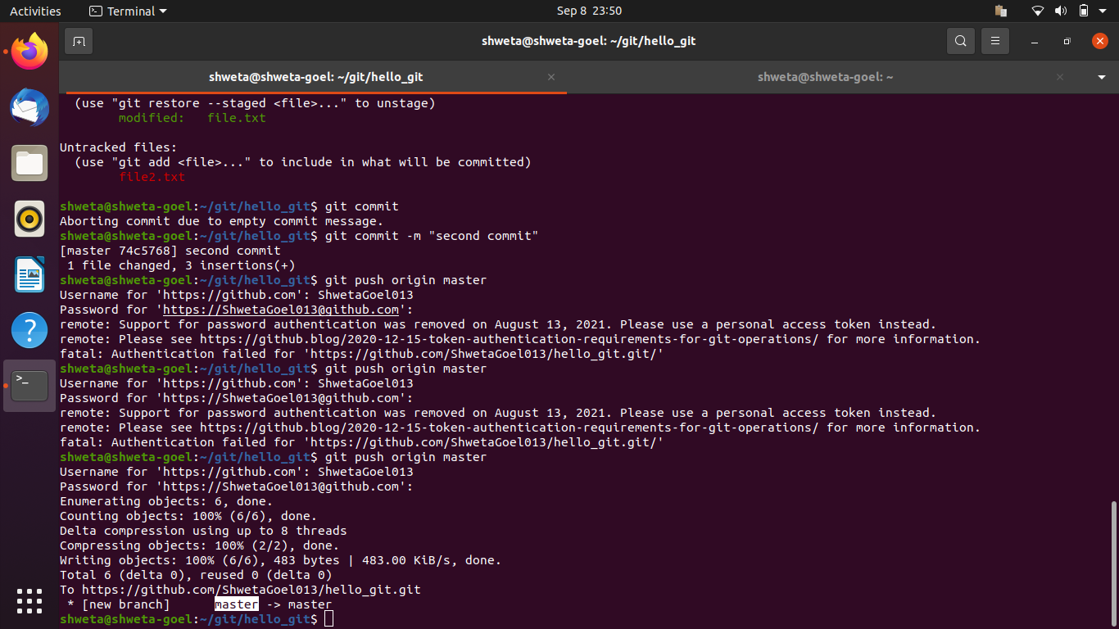

9. Clone the repository.

Ans :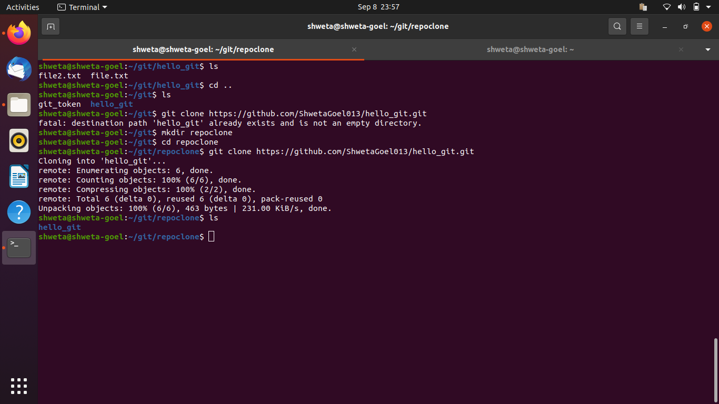

10. Add changes to one of the copies and pull the changes in the other.

Ans :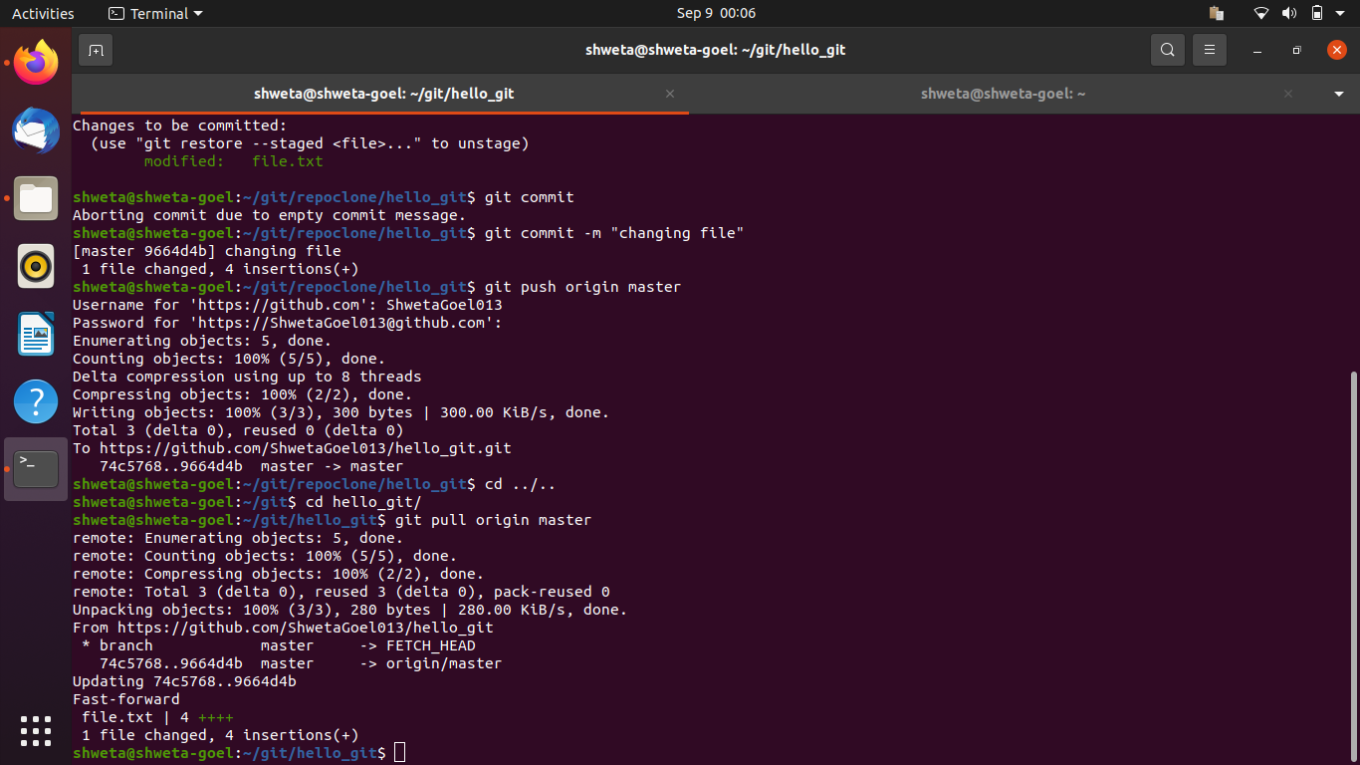

11. Check differences between a file and its staged version.

Ans: 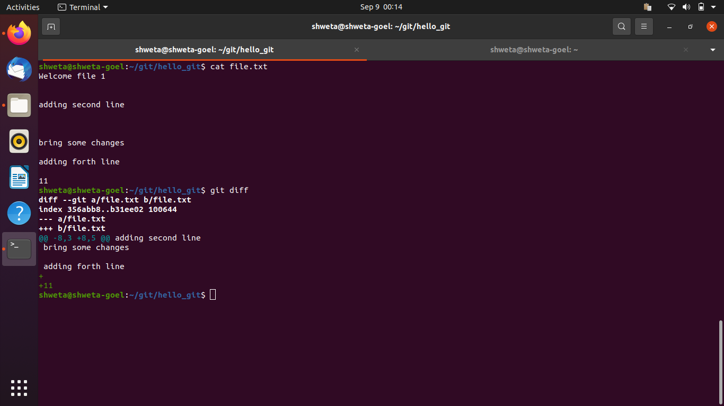

12.Ignore a few files to be checked in.

Ans : 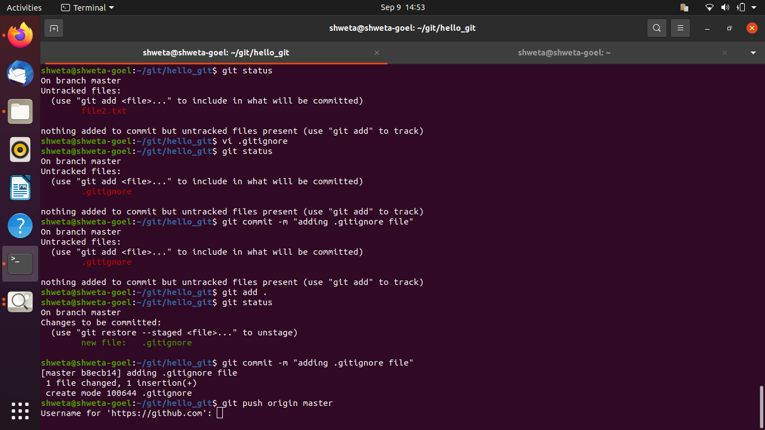

13. Create a new branch.

Ans :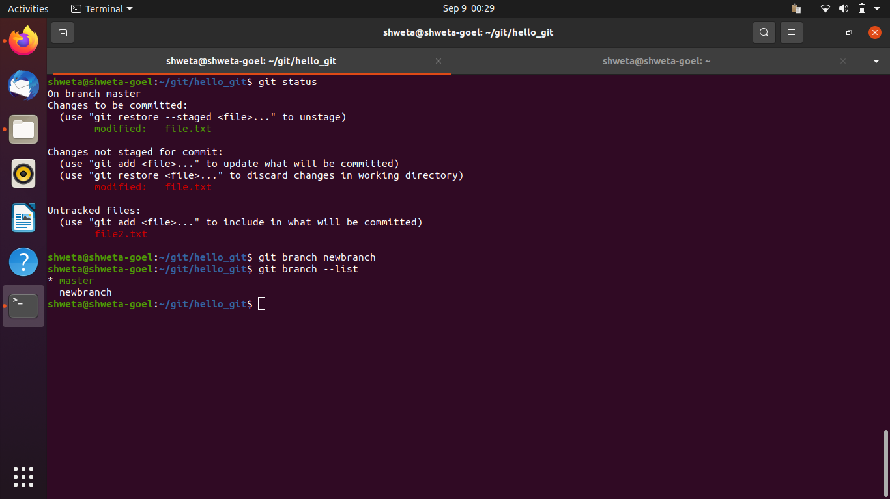

14.Diverge them with commits.

Ans : 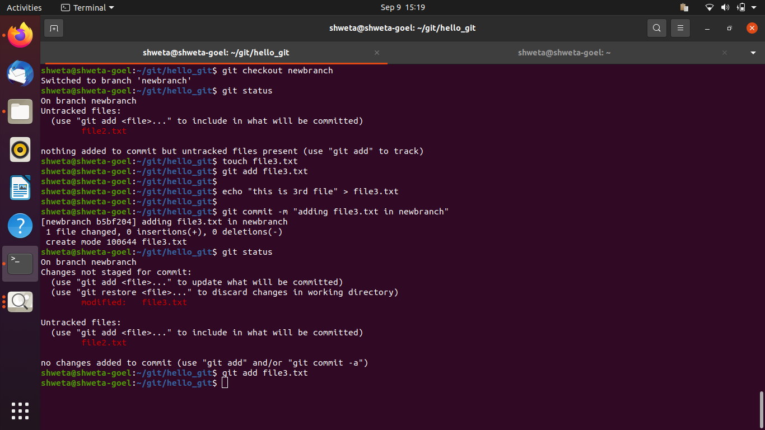

15. Edit the same file at the same line on both branches and commit.

Ans : 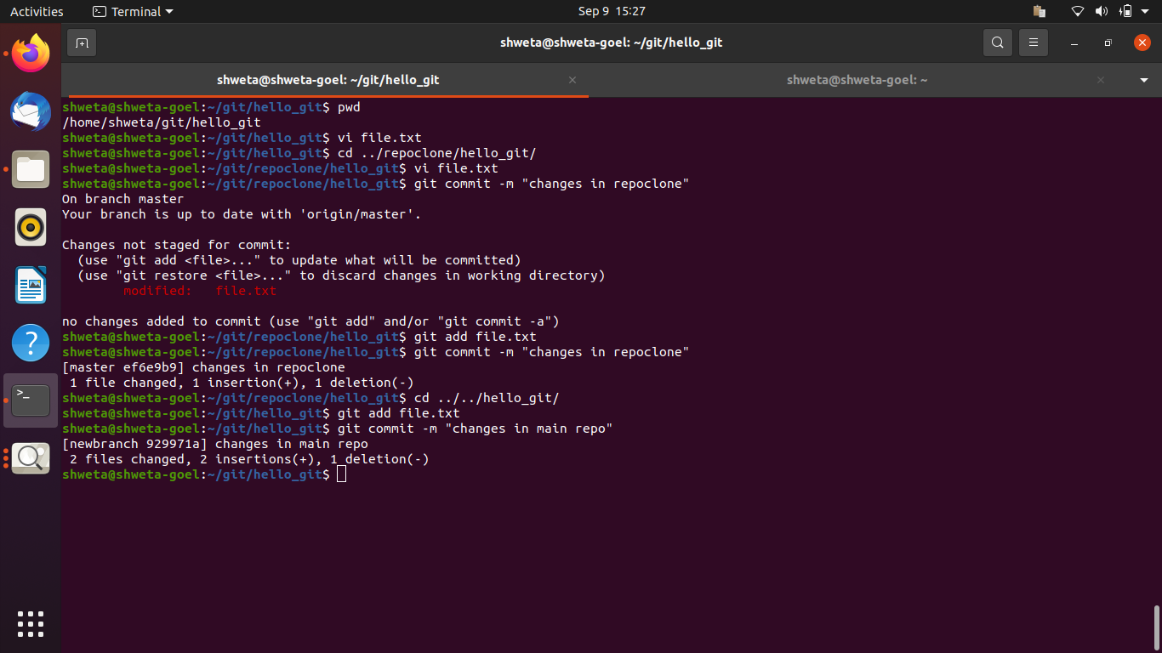

16. Try merging and resolve merge conflicts.

Ans : 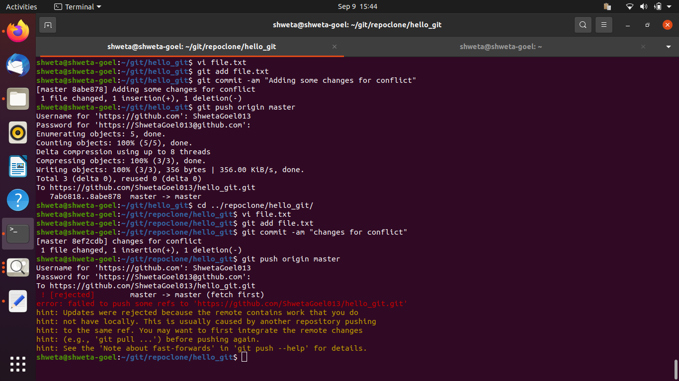

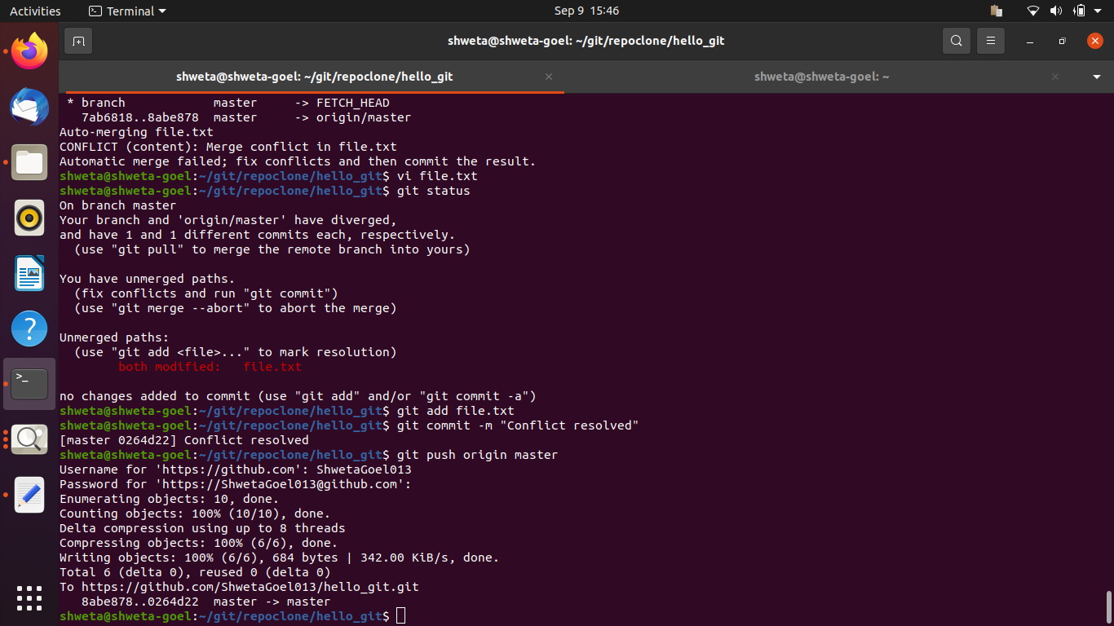

17. Stash the changes and pop them.

Ans :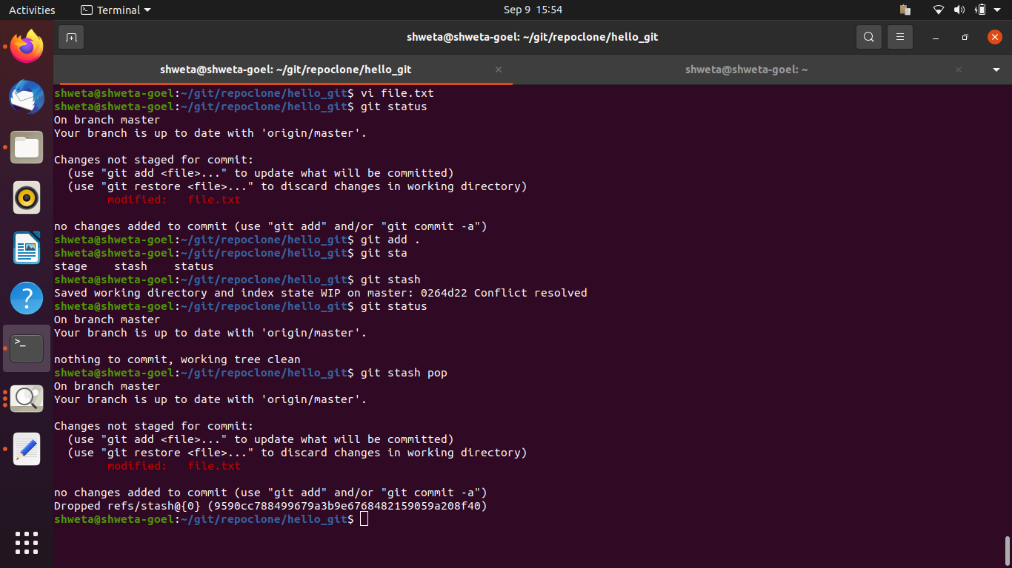

18. Add the following code to your .bashrc file : color_prompt="yes"

parse_git_branch() {

git branch 2> /dev/null | sed -e '/^[^*]/d' -e 's/* \(.*\)/(\1)/'

}

if [ "$color_prompt" = yes ]; then

PS1='\u@\h\[\033[00m\]:\[\033[01;34m\]\W\[\033[01;31m\] $(parse_git_branch)\[\033[00m\]\$ '

else

PS1='\u@\h:\W $(parse_git_branch)\$ '

fi

unset color_prompt force_color_prompt

Ans : 